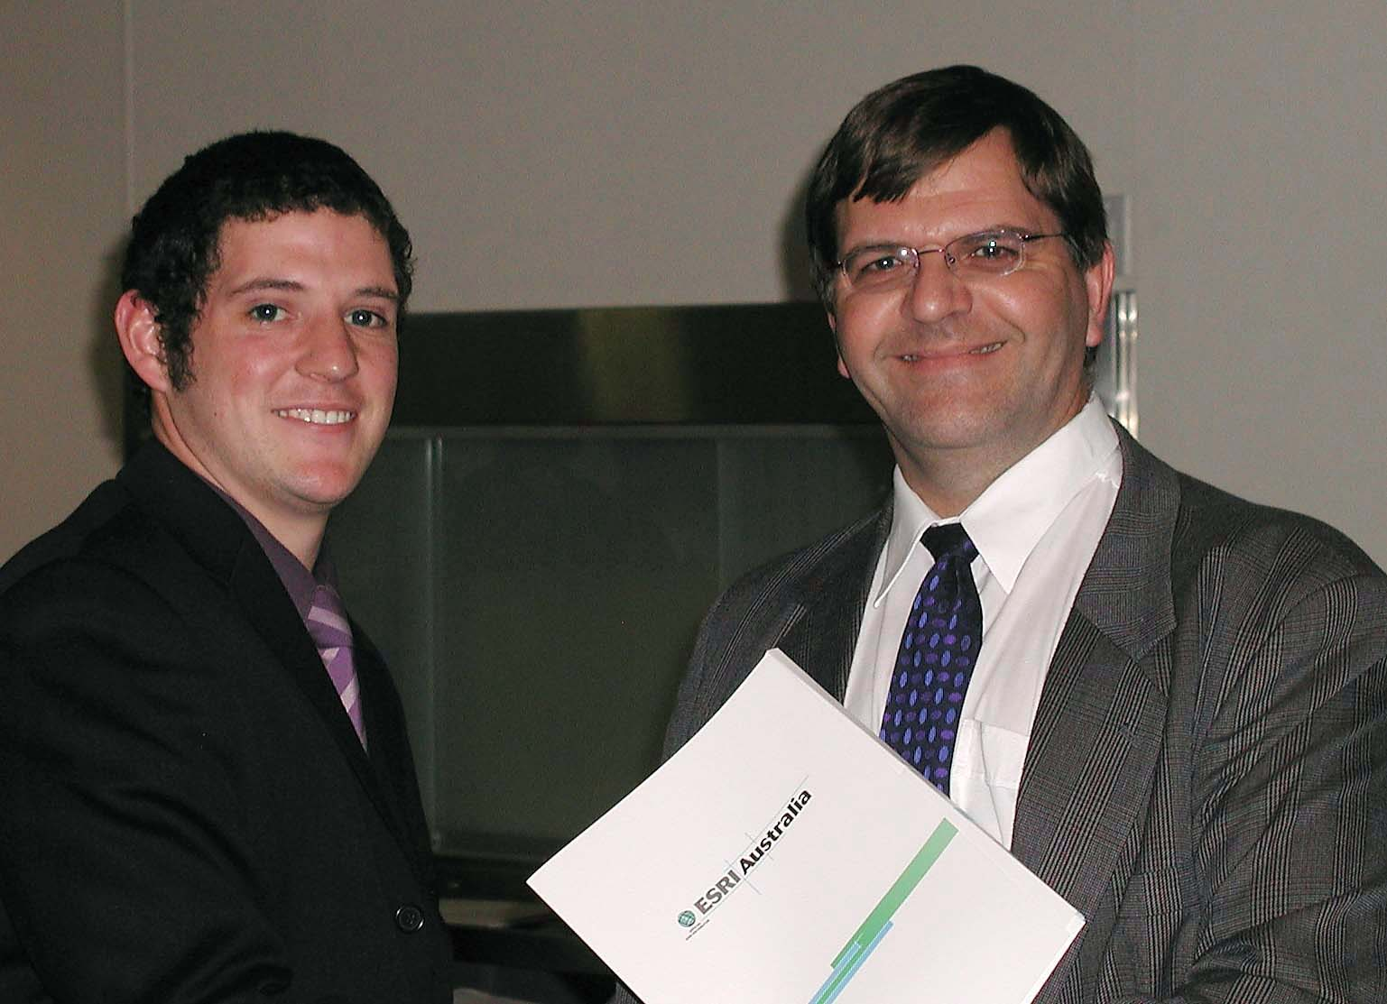
Brendan Phasey – ESRI Prize Winner
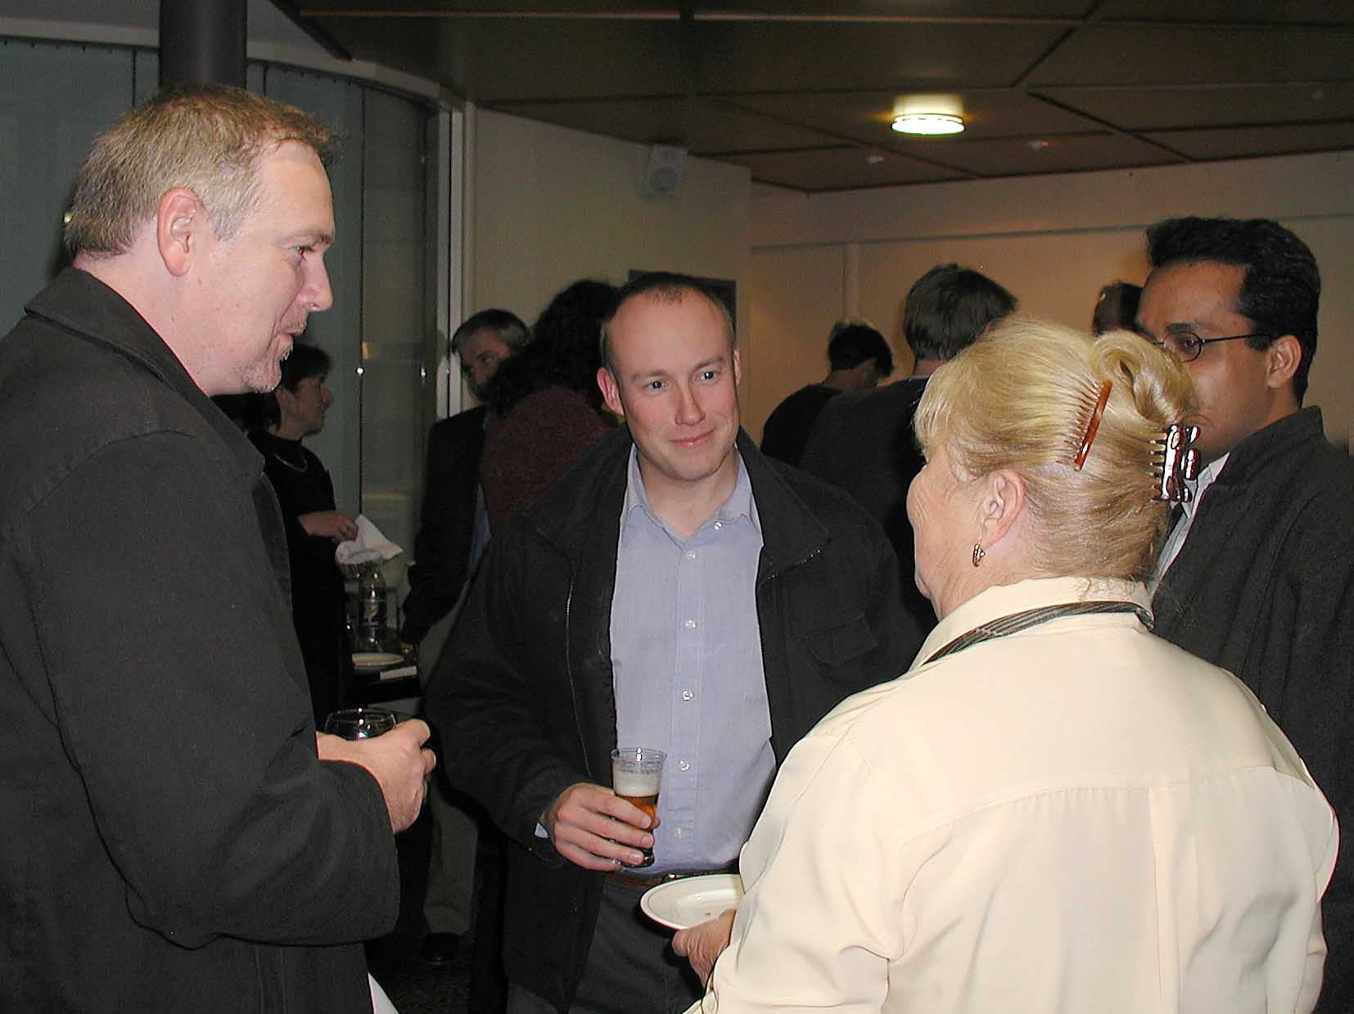
Steve Fildes, Paul Dare and Yvonne Haby
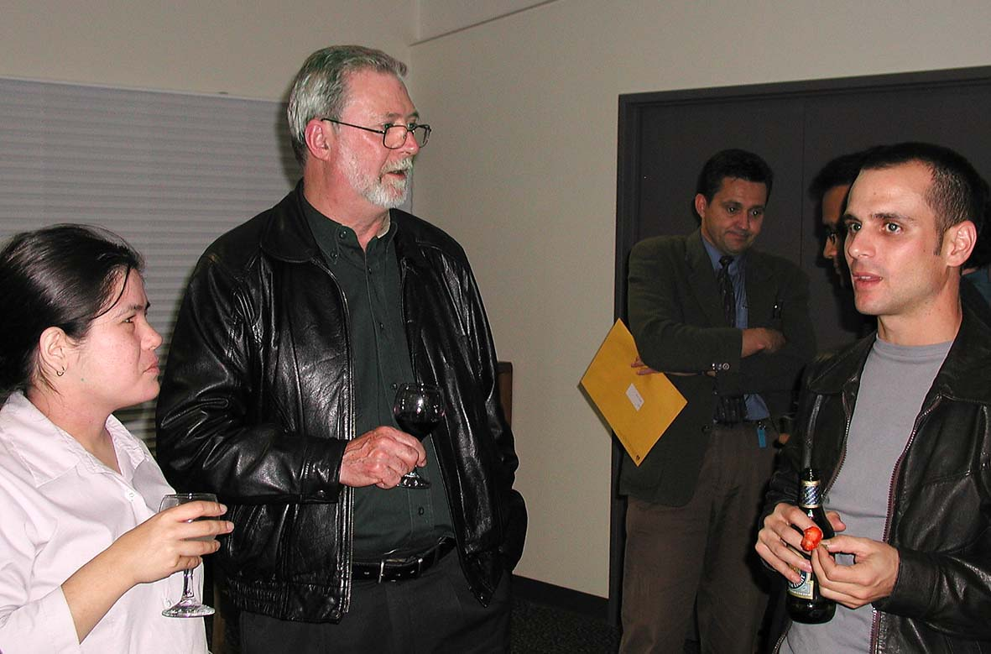
Susan Lee and Clive Forster with Edoardo Rosso
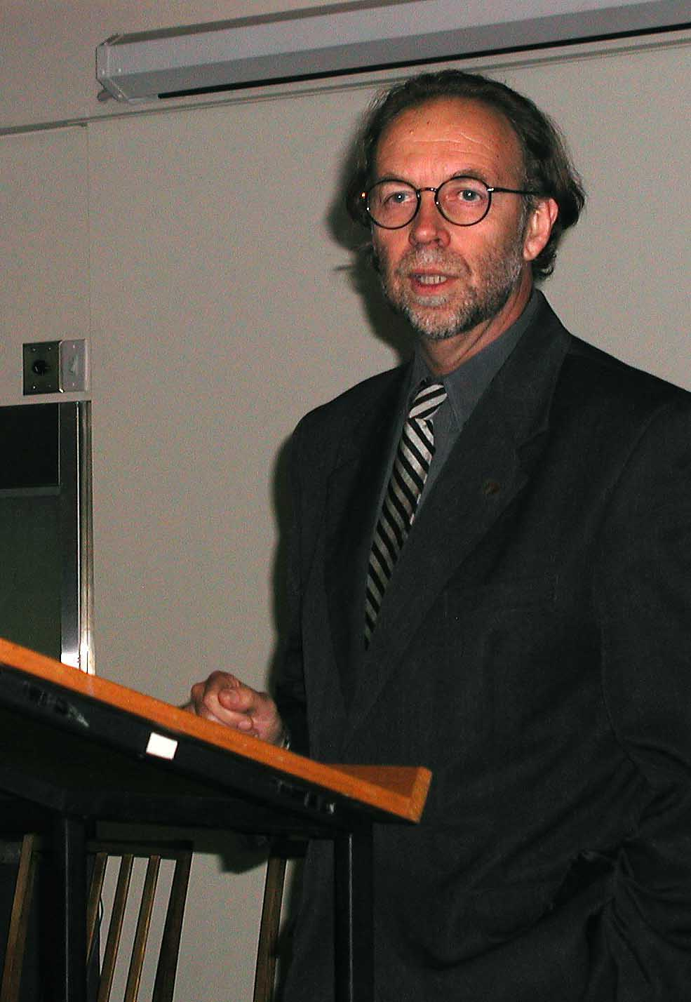
Dean Forbes
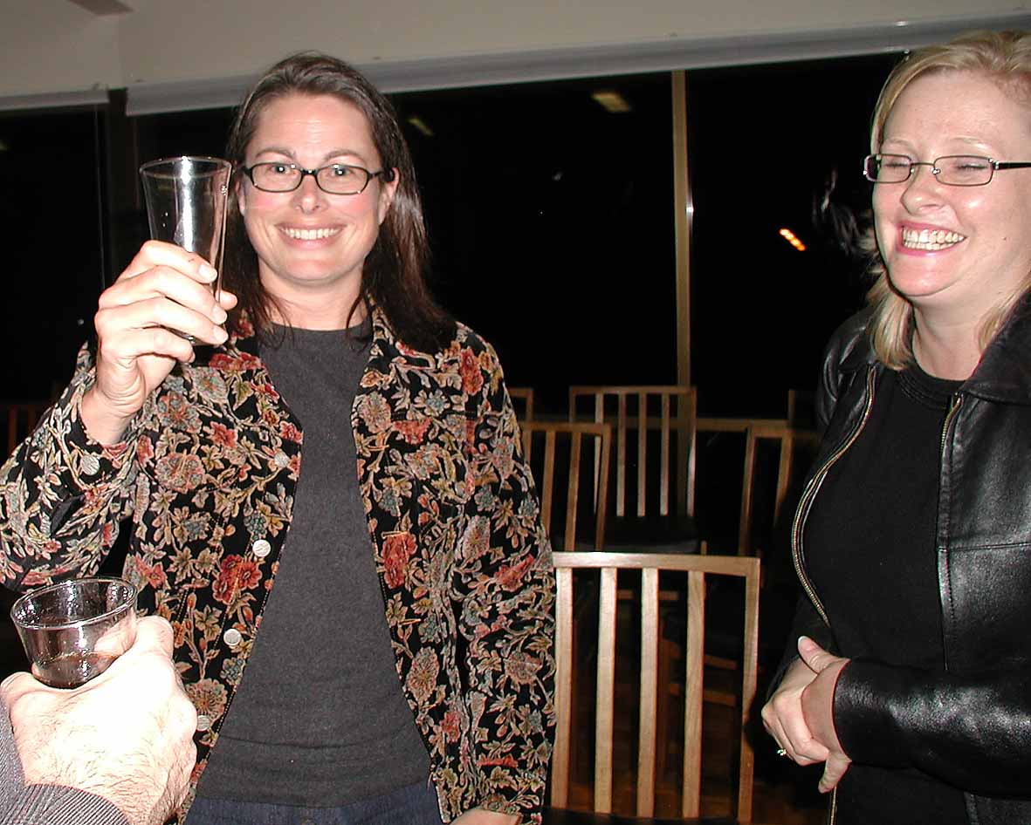
Beverley Clarke and Emma Baker
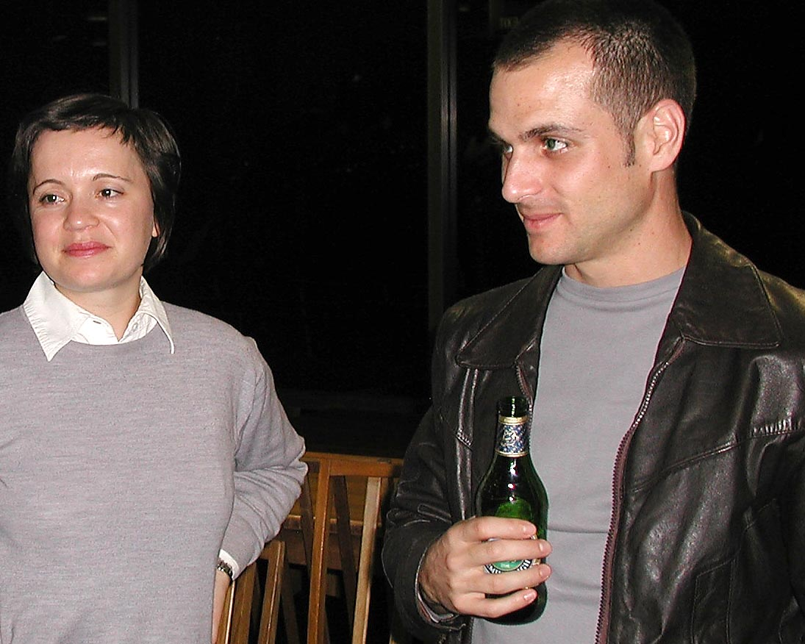
Edoardo Rosso – 1st Year John Lewis Prize Winner
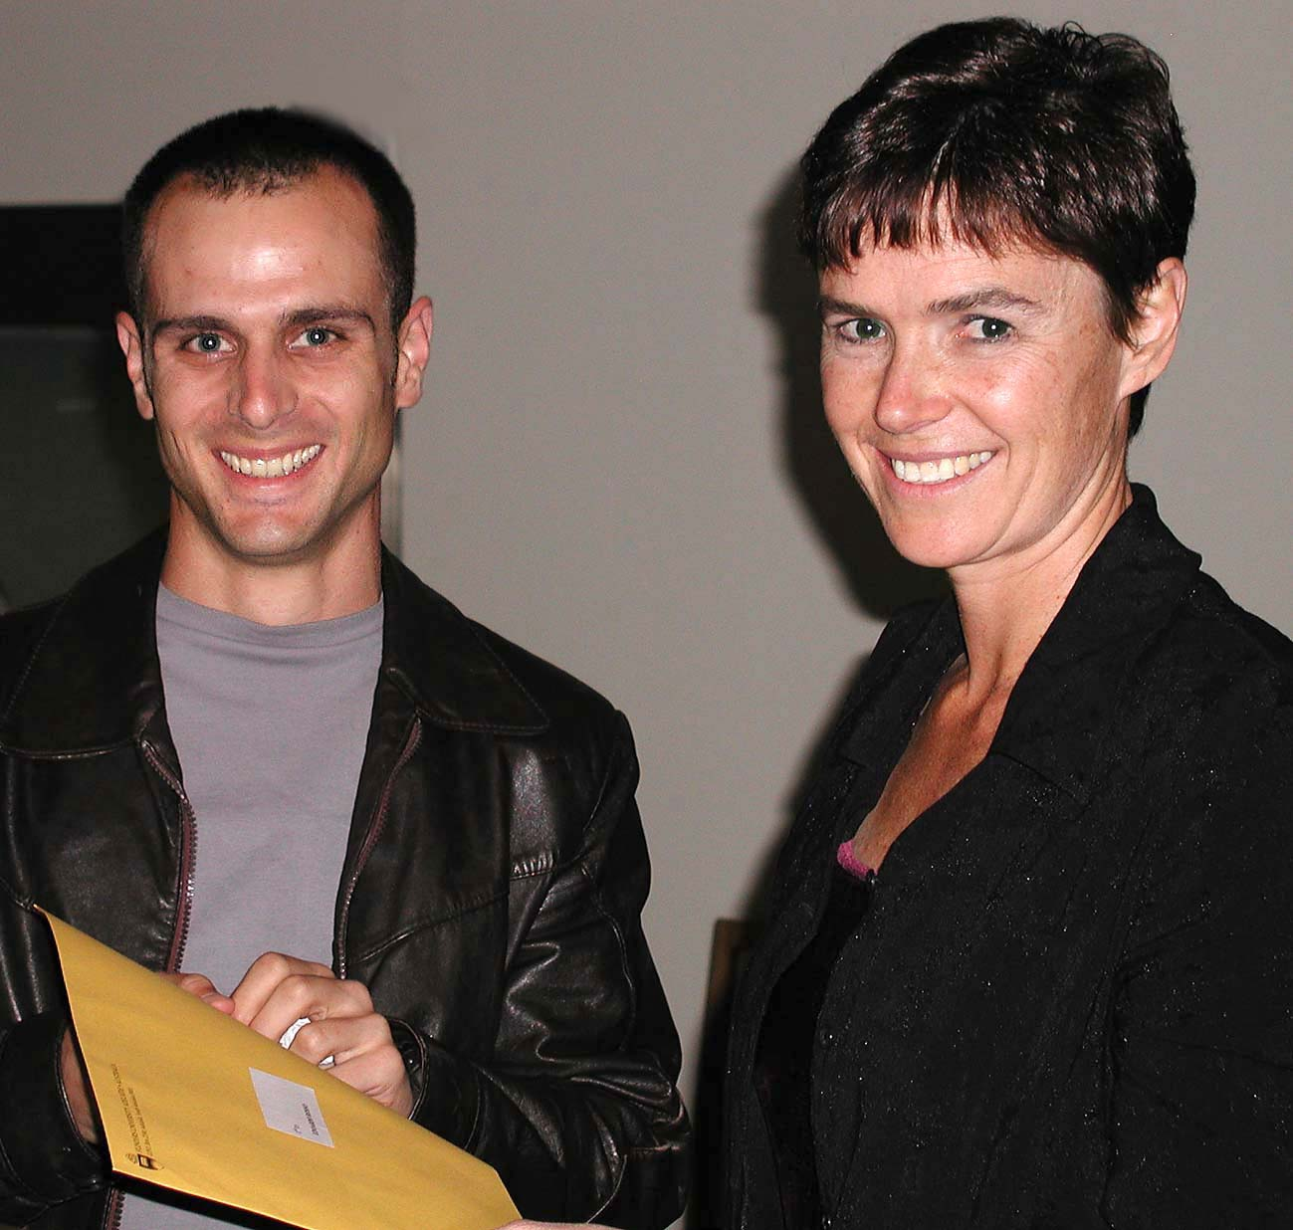
Edoardo Rosso with Meryl Pearce
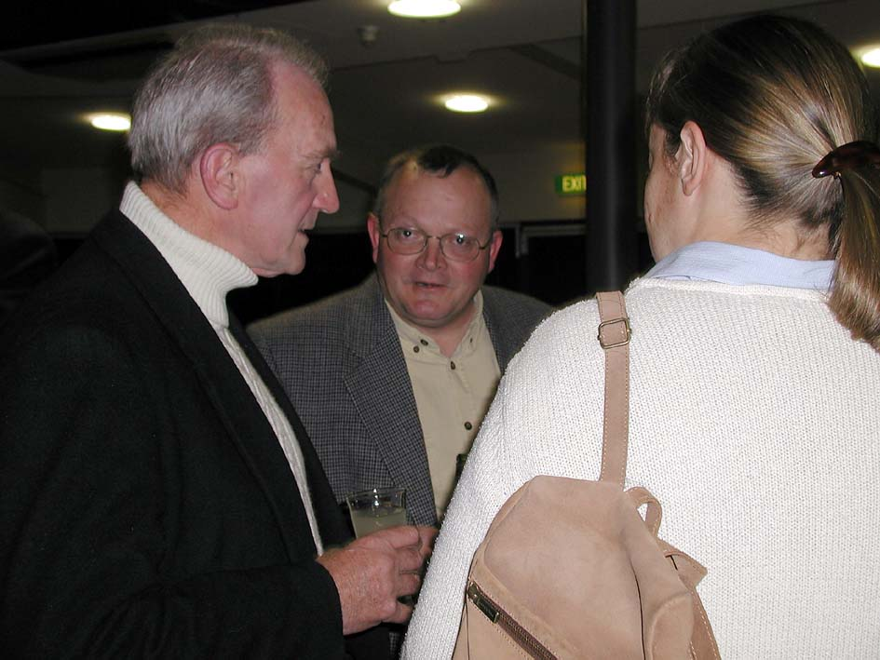
Stewart Fraser with Noel Richards
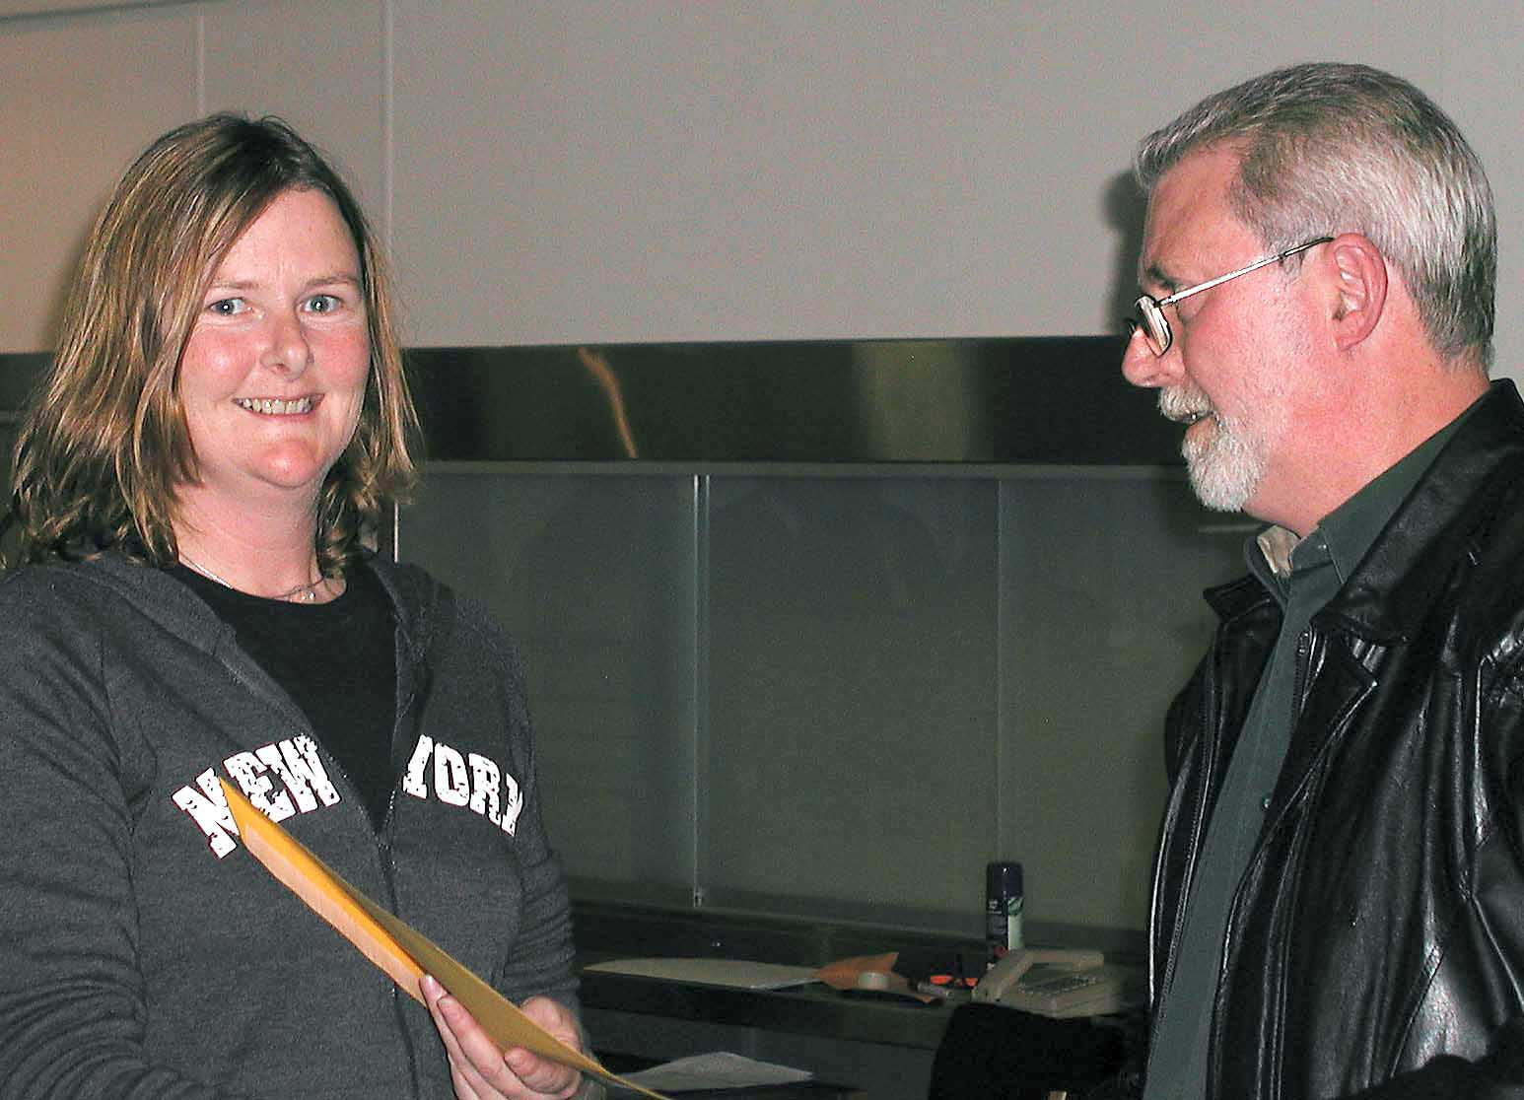
Jackie Watts – Winner of the McCaskill Medal and the Les Heathcote Award with Clive Forser
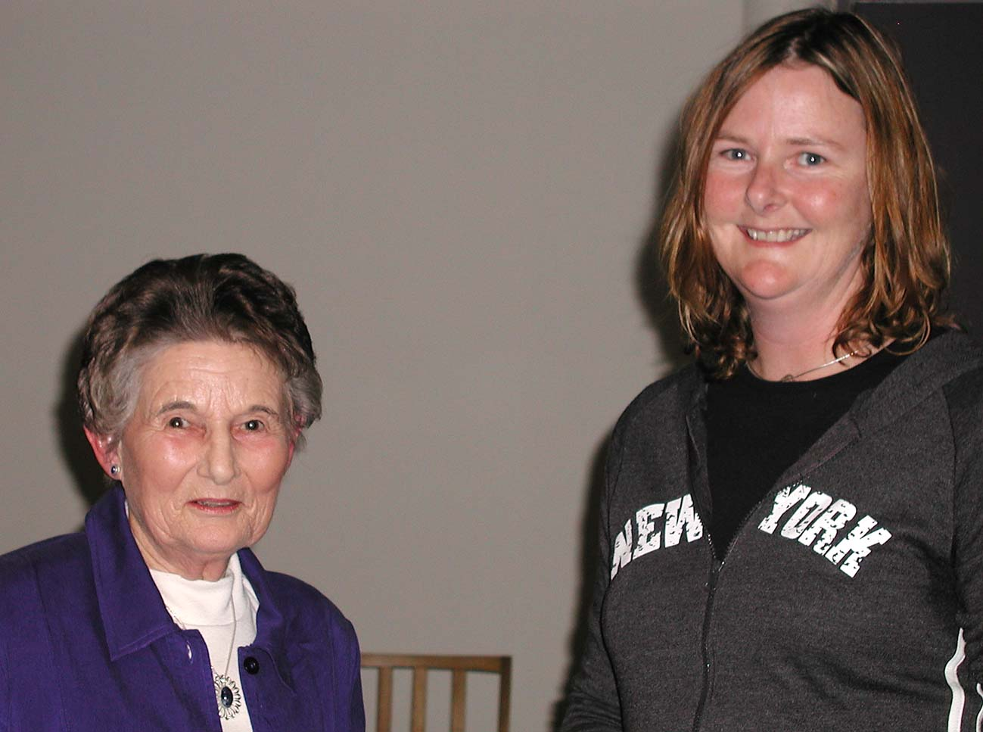
Margaret McCaskill with Jackie Watts
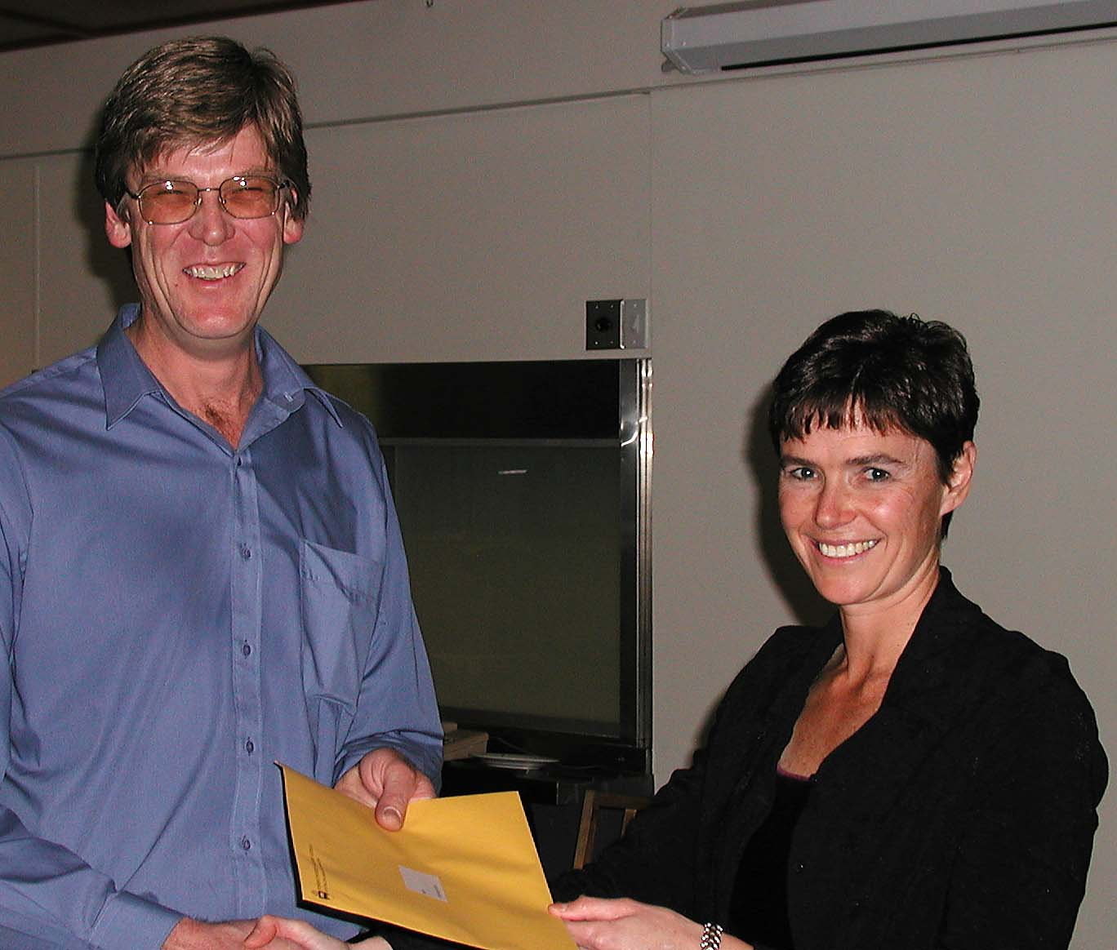
John McArthur – 2nd Year John Lewis Prize Winner
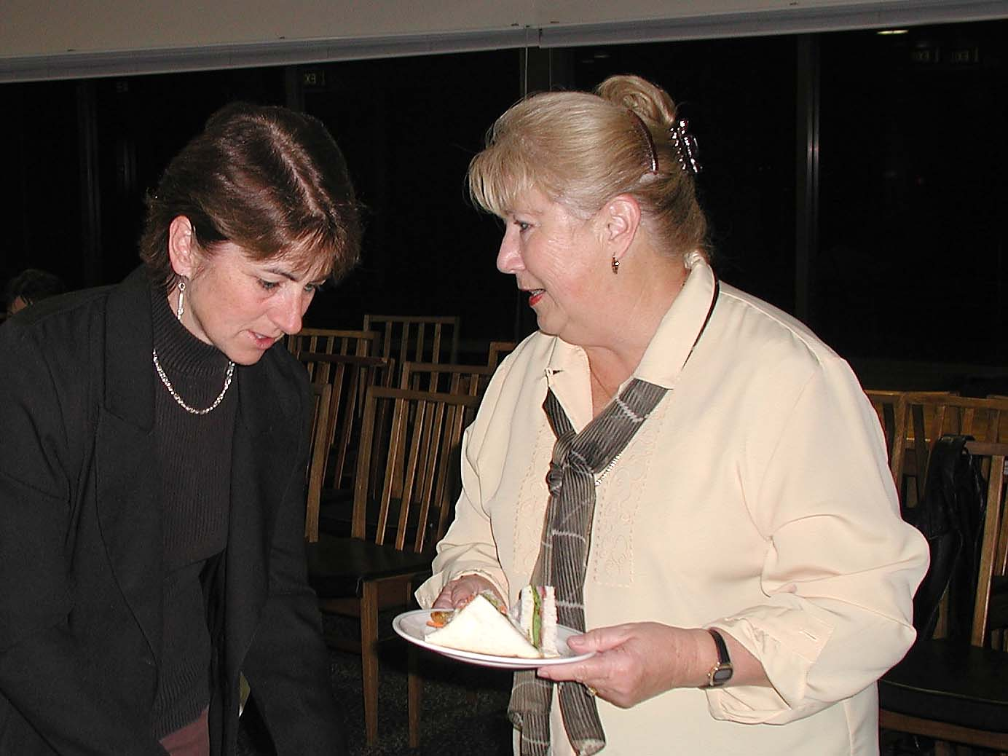
Louise O’Loughlin and Yvonne Haby
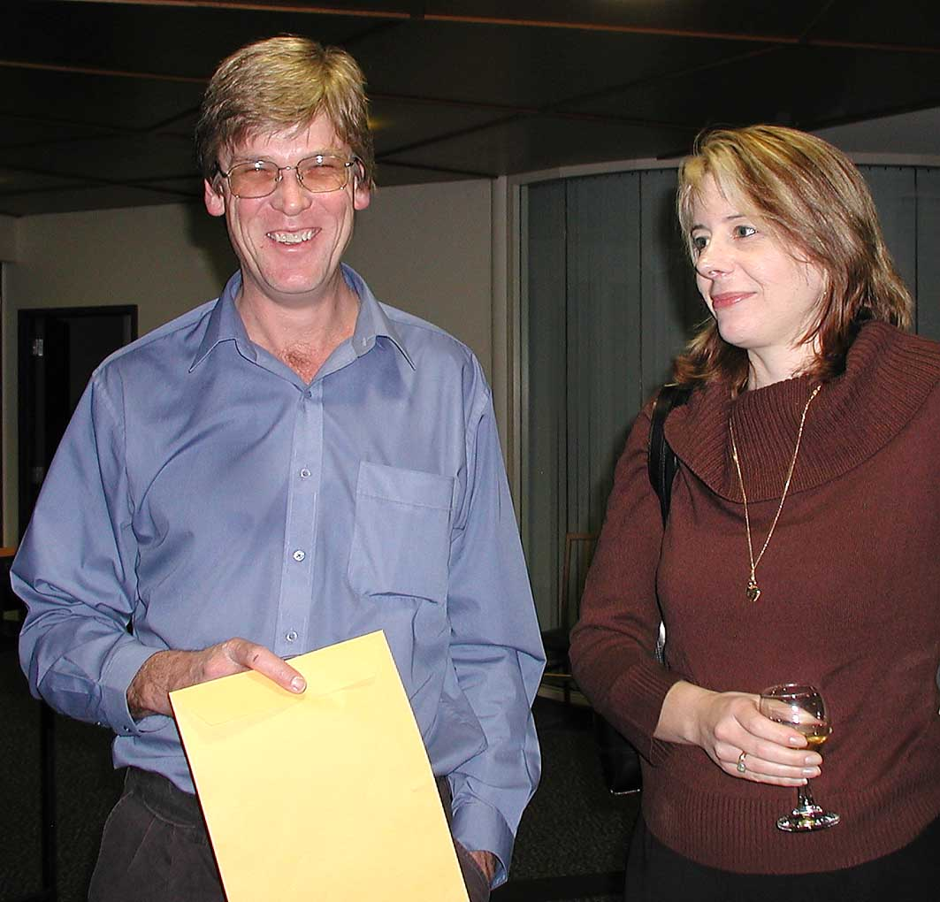
John McArthur and his wife
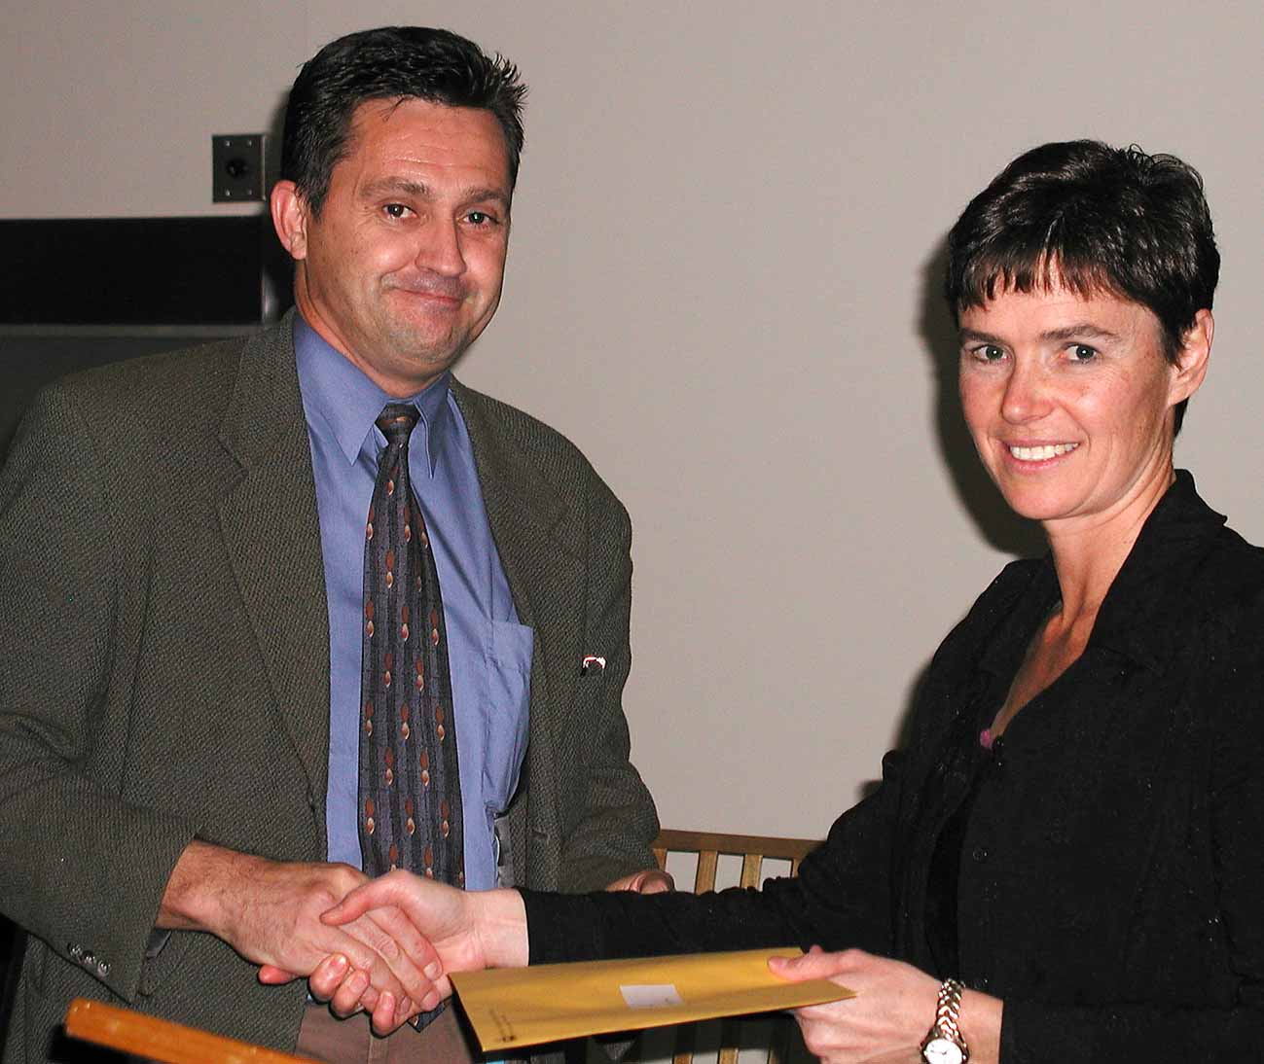
Mark Tutton – 3rd Year John Lewis Prize Winner with Meryl Pearce

