Bougainville Human Development Report Workshops

Udoy Saikia along with UNDP Coordinator Dr. Jim Chalmers organised three workshops (two in Bougainville and one in Port Moresby) as a part of the ongoing project on Bougainville Human Development Report (BHDR). The workshops were held from 18th to 21st April 2006. The first workshop was to consult and finalise the fieldwork strategies and research questionnaires for the BHDR project. Around 16 participants attended the first workshop and they were all from the local community and local NGOs who would be involved in the fieldwork. The next two workshops were attended by authors of the background papers for the report. Most of the contributing authors were prominent Bogainvillieans including the group of three female authors who were nominated for Nobel Peace Prize for their contribution to the successful peace process. The fieldwork will be in two stages- one at a village level reflecting on socio-economic profile and the other one at individual level exploring the existing skills and knowledge. It will be conducted in three months time- May—July 2006.The target population during the fieldwork will be in the age group of 15-35, the age group that missed out in education during the conflict in Bougainville.

Photograph 1:

Udoy Saikia and Jim Chalmers (UNDP Coordinator) with research investigators in Bougainville

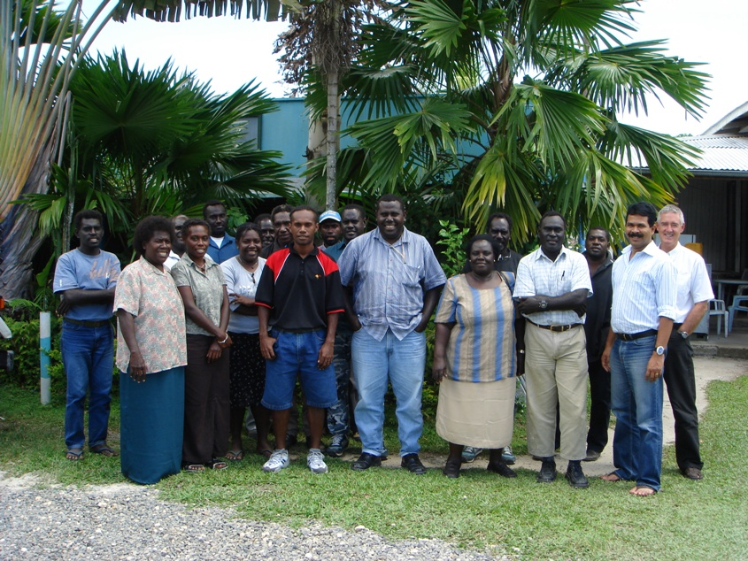

Photograph 2:

Udoy Saikia with the group nominated for Nobel Peace Prize
Sr Lorraine Garasu (extreme left), Josephine Sirivi (extreme right) and Helen Hakena (second from right).

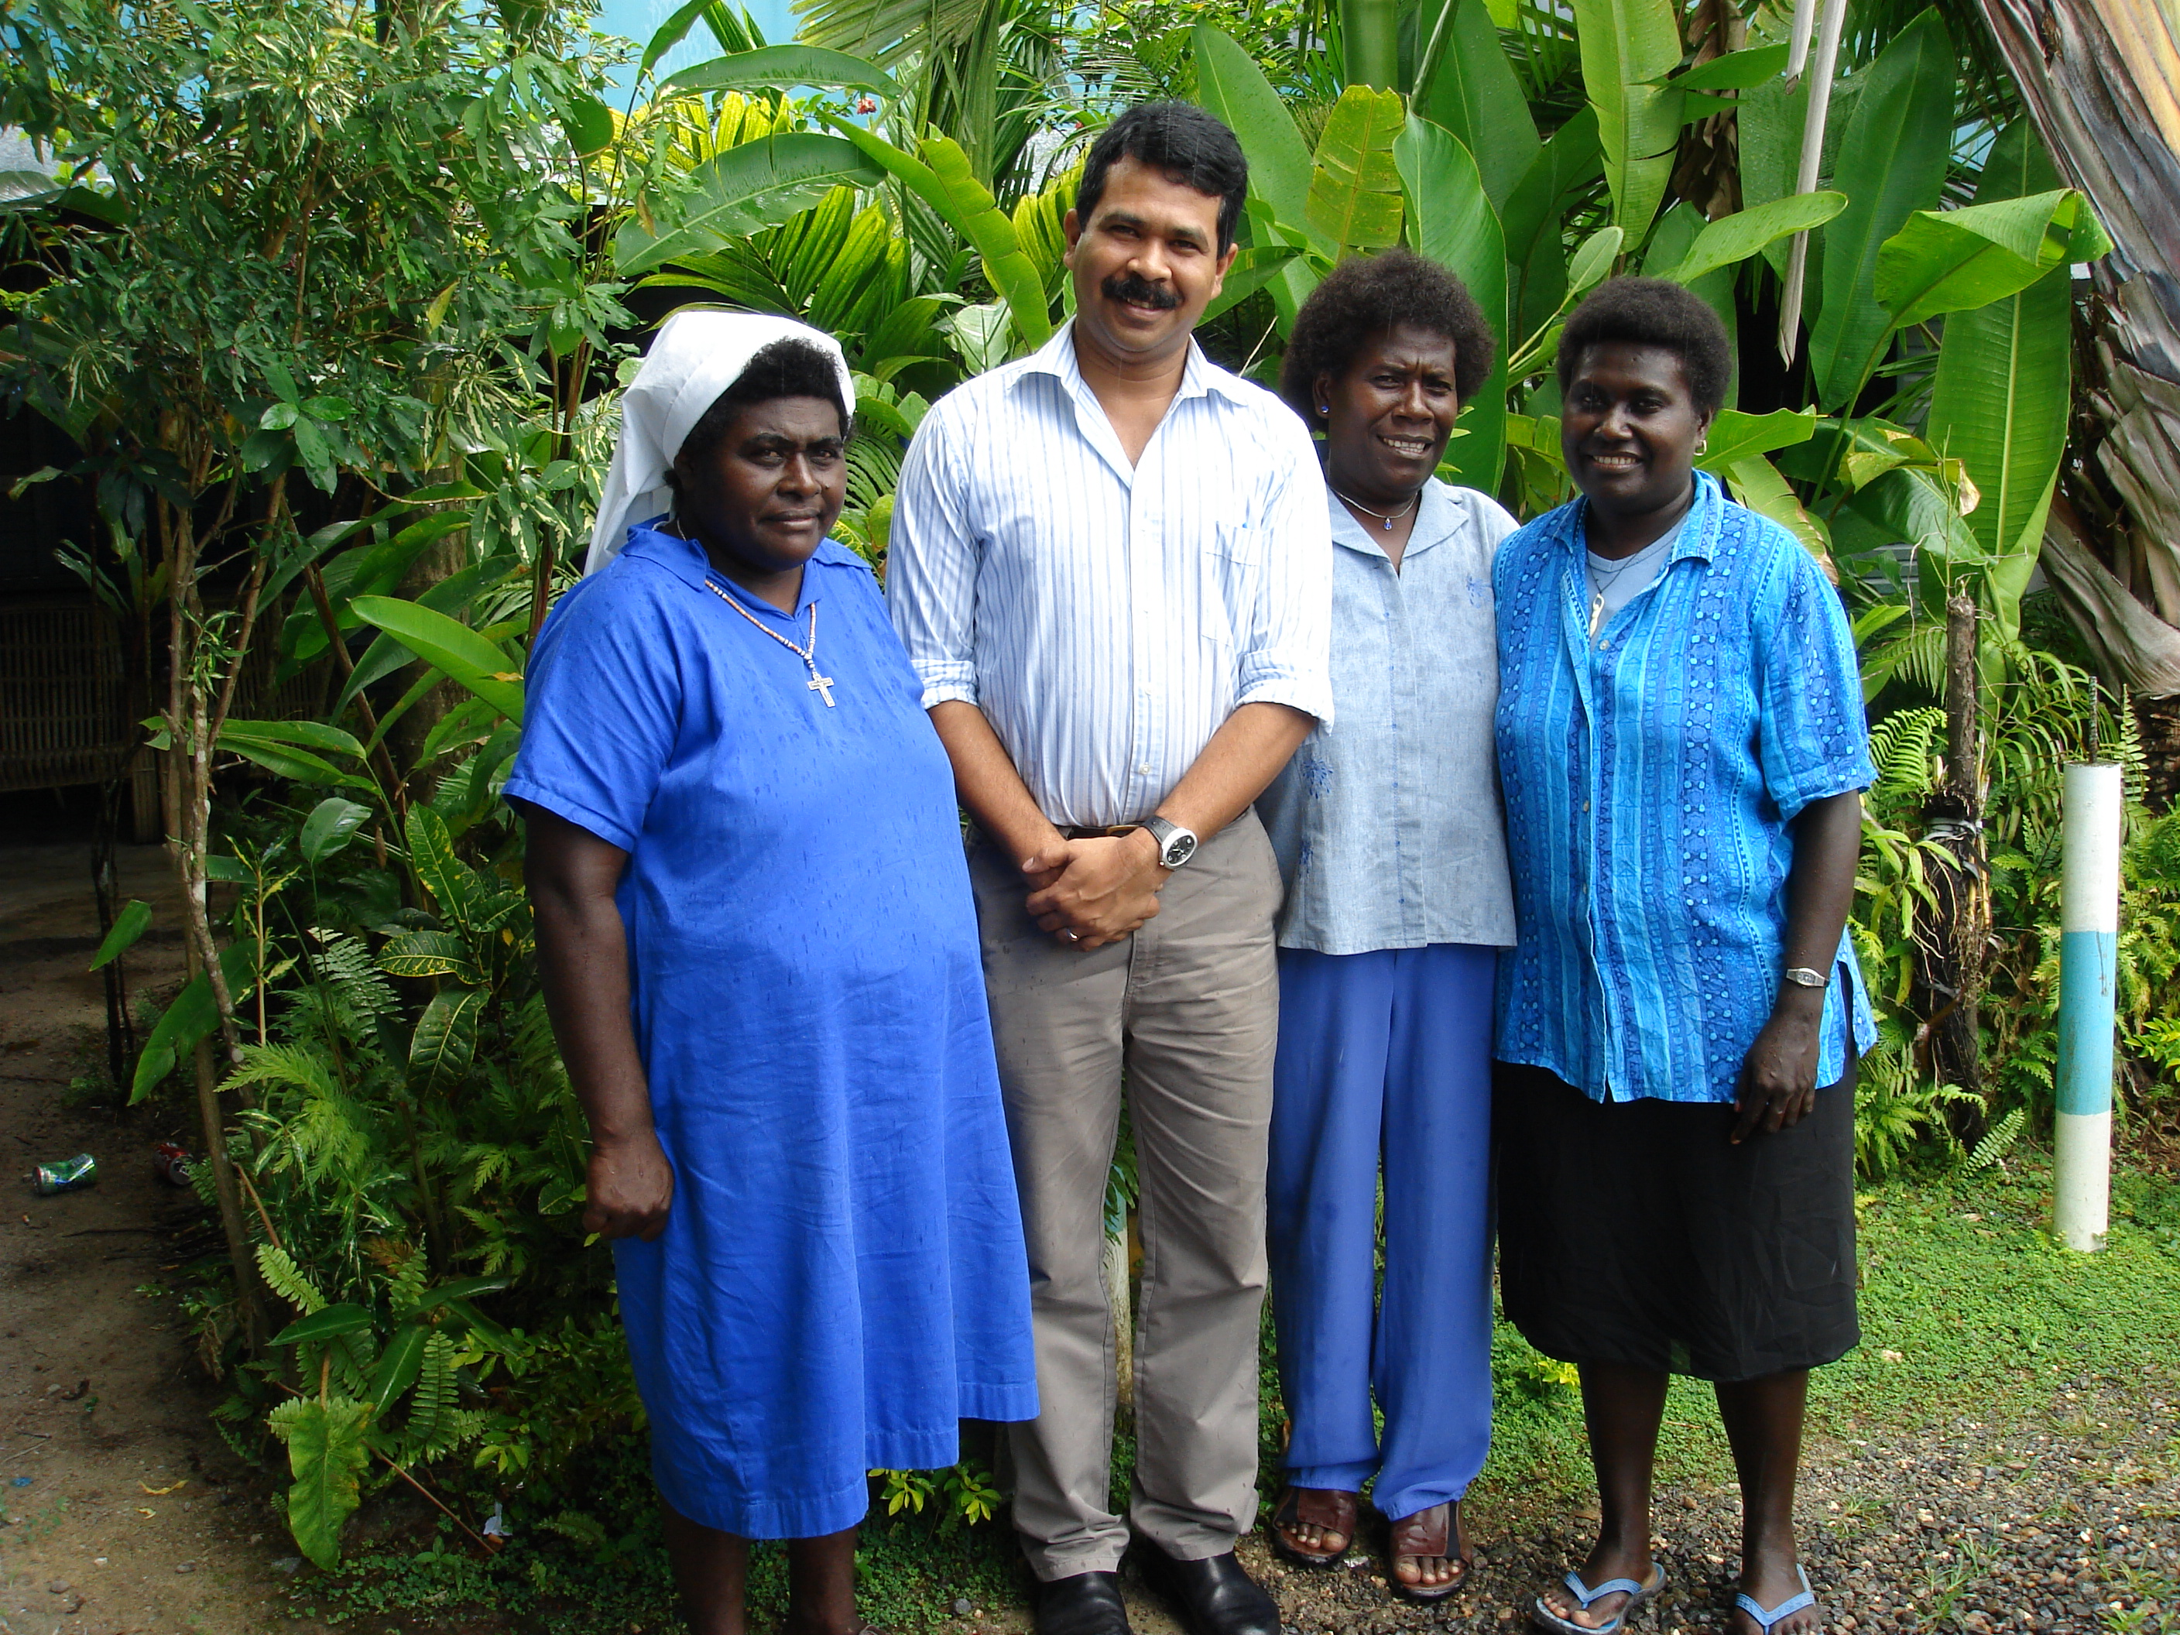

Photograph 3:

During the workshop
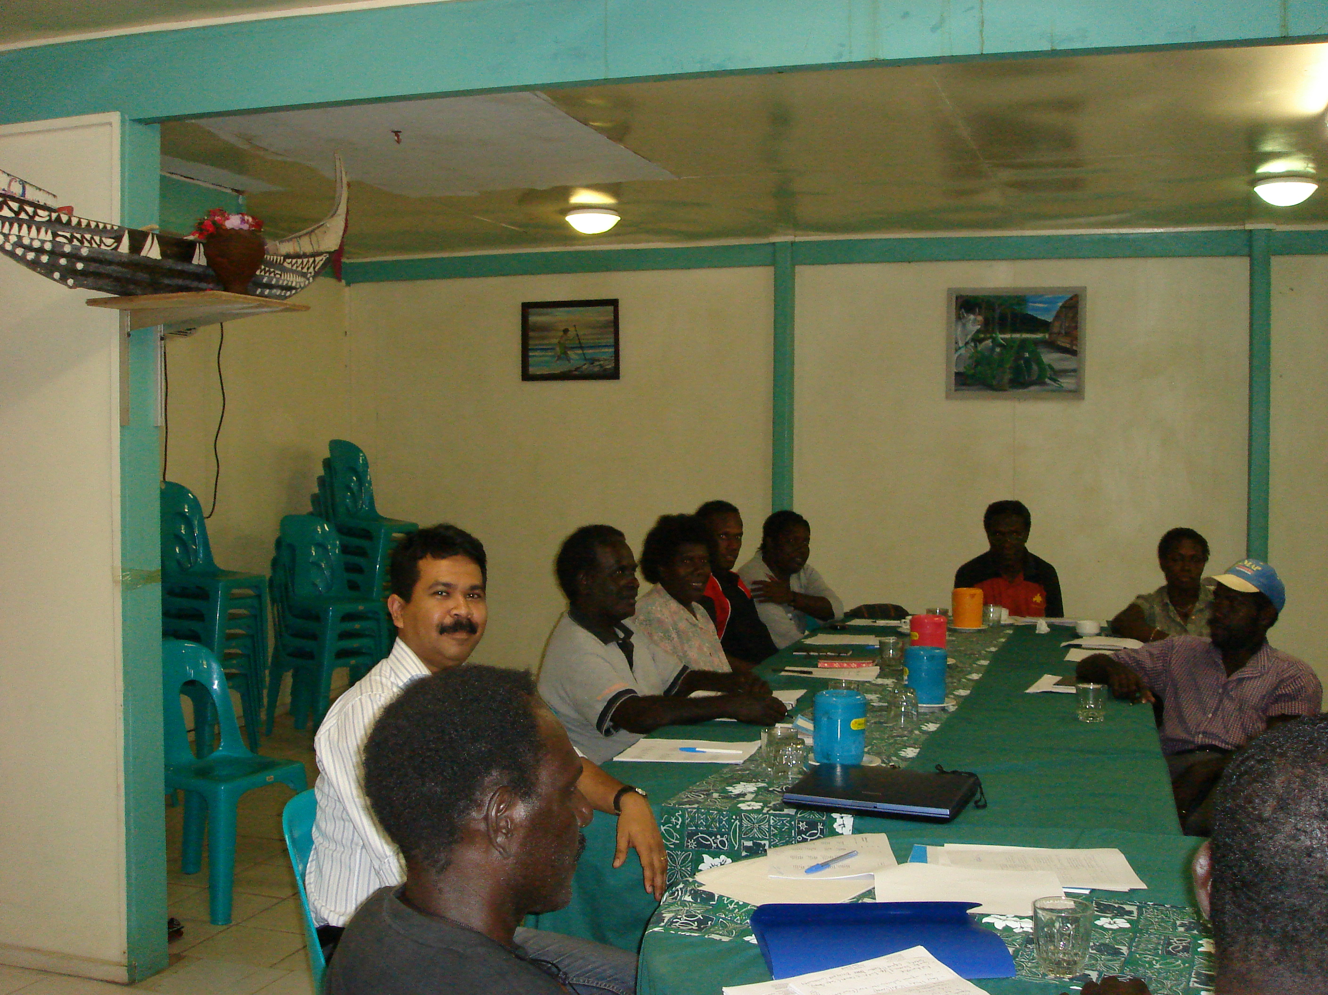

Photograph 4:

More than 20 rivers in Bougainville without bridges where people have to take risk driving through them every day



